Artifact Two Narrative

The second artifact I selected is from my CS 300: Data Structures and Algorithms - Analysis and Design course. This program was created when I took this course in the spring of 2023. It was designed to open a file and read the data within into a data structure, sort that data in alphabetical order, and search and display any requested data. I chose this artifact as I felt it would be a great example to showcase an understanding of how algorithms and data structures work together and the importance of efficiency when using algorithms, especially with large data structures. This program was initially developed to use the linear search and selection sort algorithms. For my planned enhancements, I wanted to test different sorting algorithms, to possibly increase the efficiency of the program. I didn’t need to test different search algorithms and the linear search algorithm is best if the data is in alphabetical order. The test for efficiency, I refactored the sorting function to utilize the bubble sort and insertion sort, and did a Big O analysis for each. After running Big O analysis on all 3 sorting algorithms, I determined that each had the same efficiency rating, therefore, I left the program as is. I pasted a screenshot of each function with the Big O analysis written in the comments. For submission, I submitted a version of the original code with the selection sort along with versions that have been refactored with both the bubble and insertion sort. I feel that my Big O analysis of each sorting algorithm met course outcomes of “demonstrating my ability to use innovative techniques and tools for computing practices”, and “designing and evaluating computer solutions to solve a given problem using algorithmic principles”. By undertaking this planned enhancement, I was able to refresh my knowledge of algorithm efficiency and Big O analysis as it’s been awhile since I’ve had to use that skill.

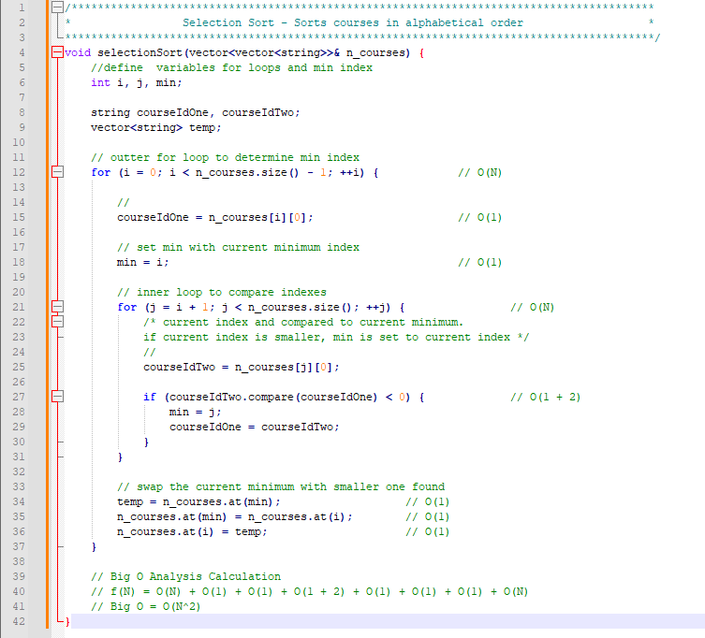**Selection Sort Big O Analysis**

**Insertion Sort Big O Analysis**

**Bubble Sort Big O Analysis**